LAB EXPERIMENT RECORD

SET 10 — Survey Responses Analysis

Department | AIDS
Course Code / Course Name | DSA0602 / Data Handling and Visualization
Experiment | Data Visualization using R
Name | GOPIKHA S
Register Number | 1924260143
Date | 6 October 2026
Day | Tuesday

Aim

To analyze survey responses using R programming by creating a grouped bar chart, a stacked bar chart, and a table, and to develop an interactive Tableau dashboard for exploring survey response data.

Dataset

Dataset Name: Survey Responses

Survey ID | Question 1 | Question 2 | Question 3
1 | A | B | C
2 | B | A | D
3 | C | A | B

Program 1 — Grouped Bar Chart for Question 1

Code (R)

R
# |  | Survey |  |  |  | response |  | data
survey |  |  |  | <- |  |  |  | data.frame(
Survey_ID  Question_1 |  | =  = |  |  | c(1,  c("A", |  | 2,  "B", | 3),  "C"),
Question_2 |  | = |  |  | c("B", |  | "A", | "A"),
Question_3 |  | = |  |  | c("C", |  | "D", | "B")
)
# | Count |  | responses |  |  | for | Question | 1
response_count <- table(survey$Question_1)

# Create grouped-style bar chart barplot(
response_count,
main = "Distribution of Answers for Question 1", xlab = "Answer Options", ylab = "Number of Responses", col = c("skyblue", "orange", "lightgreen"), ylim = c(0, max(response_count) + 1)
)

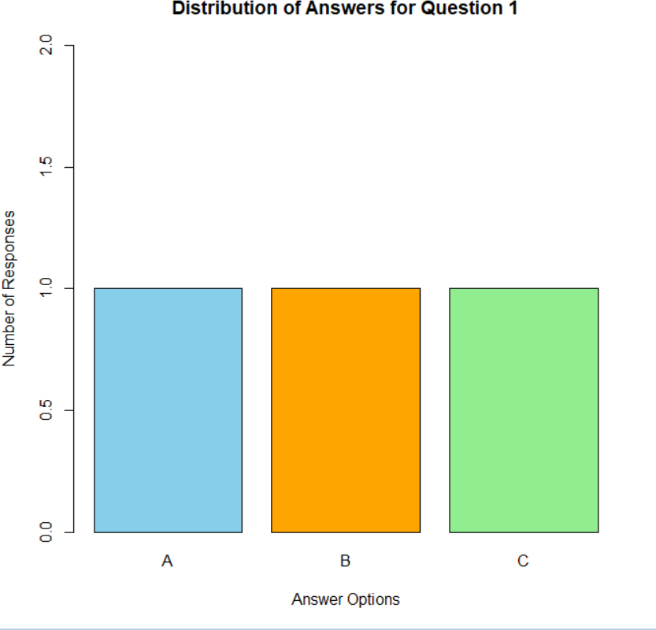

Observation

The bar chart displays the number of responses for each answer option in Question 1. Options A, B, and C each received one response. Therefore, all three options have equal representation.

Program 2 — Stacked Bar Chart for All Three Questions

Code (R) R
# Count each answer option for every question

responses  "Question | 1" | <- | = |  | rbind(  table(factor(
survey$Question_1, | levels | = c("A", |  | "B", | "C", "D")
)),
"Question | 2" |  | = |  | table(factor(
survey$Question_2, | levels | = c("A", |  | "B", | "C", "D")
)),  "Question | 3" |  | = |  | table(factor(
survey$Question_3, | levels | = c("A", |  | "B", | "C", "D")
))
)

# Create stacked bar chart barplot(
t(responses),
beside = FALSE, main = "Distribution of Responses for All Questions", xlab = "Questions", ylab = "Number of Responses", col = c("skyblue", "orange", "lightgreen", "pink"), legend.text = rownames(responses), args.legend = list(x = "topright", cex = 0.7)
)

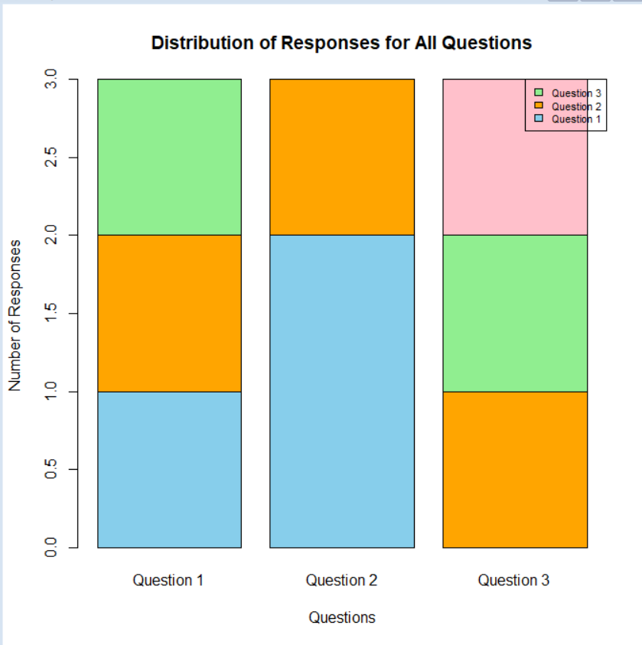

Observation

The stacked bar chart compares the distribution of answers across the three questions. Question 1 contains A, B, and C; Question 2 contains A and B; and Question 3 contains B, C, and D. Each question has three responses.

Program 3 — Display Survey Response Data in a Table

Code (R)

R
# Display |  | the |  |  |  | complete |  |  | survey | data
survey |  |  |  |  | <- |  |  |  |  | data.frame(
Survey_ID | = |  |  |  |  | c(1, |  |  | 2, | 3),
Question_1 | = |  |  |  |  | c("A", |  |  | "B", | "C"),
Question_2 | = |  |  |  |  | c("B", |  |  | "A", | "A"),
Question_3 | = |  |  |  |  | c("C", |  |  | "D", | "B")
)
# | Print |  |  |  |  |  |  | the |  | table
print(survey)
# Display | the |  | table |  |  | in |  | a | formatted | layout
if (requireNamespace("knitr", quietly = TRUE)) { knitr::kable(
survey,
caption | = |  |  | "Survey |  |  |  | Response |  | Data",
col.names |  |  |  |  |  |  | = |  |  | c(
"Survey |  | ID", |  |  |  |  |  | "Question |  | 1",
"Question |  | 2", |  |  |  |  |  | "Question |  | 3"
)
)
}

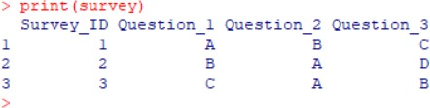

Observation

The table presents the responses of all three survey participants. It clearly displays the answers to each question and makes it easy to compare individual responses.

Program 4 — Tableau Interactive Dashboard

Objective: To combine the grouped bar chart, stacked bar chart, and survey response table into an interactive dashboard.

Step 1 — Prepare the dataset

  - Open Microsoft Excel.
  - Enter the survey data using the columns Survey_ID, Question_1, Question_2, and Question_3.
  - Save the file as Survey_Responses.csv.

Step 2 — Import the dataset

- Open Tableau.
- Select Connect → Text File.
- Select Survey_Responses.csv.
- Check that all four columns are correctly recognized.

Step 3 — Create the bar chart for Question 1

- Open a new worksheet.
- Drag Question_1 to Columns.
- Drag Survey_ID to Rows.

- Change the aggregation of Survey ID to Count.
- Select Bar Chart.
- Turn on Show Mark Labels.
- Title the worksheet Distribution of Answers for Question 1.

Step 4 — Create the stacked bar chart

- Create another worksheet.
- Select Question_1, Question_2, and Question_3 for analysis.
- If necessary, use Tableau's Pivot option in the Data Source tab to convert these columns into two fields: Question and Answer.
- Drag Question to Columns.
- Drag Number of Records or COUNT(Answer) to Rows.
- Drag Answer to Color.
- Ensure Analysis → Stack Marks → On is selected.
- Title the worksheet Overall Distribution of Survey Responses.

Step 5 — Create the survey table

- Open a new worksheet.
- Drag Survey_ID, Question_1, Question_2, and Question_3 to Rows or the Text marks card as appropriate.
- Select Text Table.
- Display all survey records.
- Title the worksheet Survey Response Data Table.

Step 6 — Develop the dashboard

- Select New Dashboard.
- Add the Question 1 bar chart.
- Add the stacked bar chart.
- Add the survey response table.
- Arrange all three visualizations neatly.

- Add a suitable dashboard title: Survey Responses Analysis Dashboard.
- If desired, use the bar chart as a filter to interact with the other views.
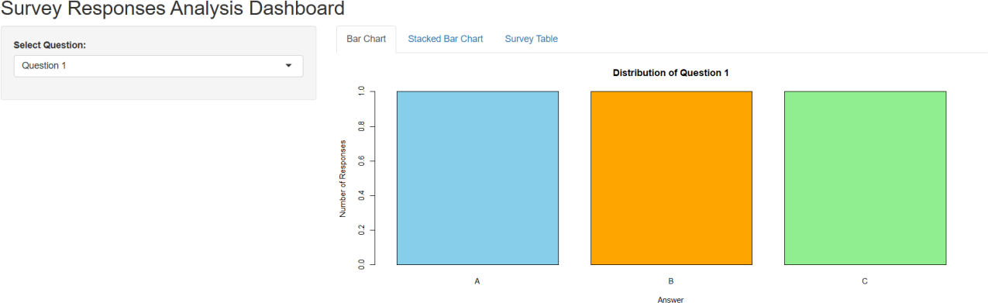

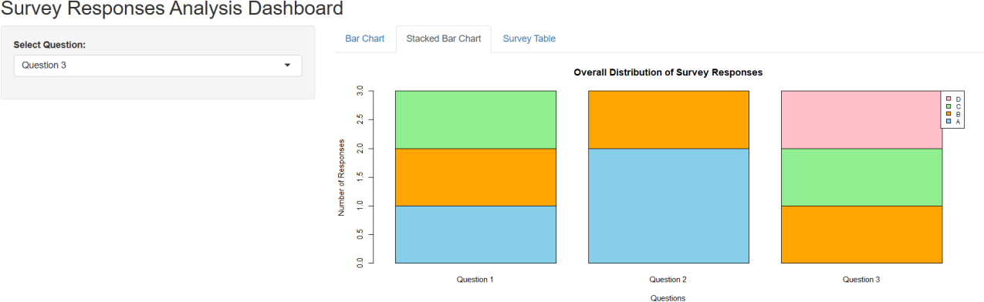

Observation

The Tableau dashboard combines all survey visualizations in one place. It allows users to compare answer frequencies and inspect individual survey responses. Interactive filtering makes the analysis easier to explore.

Overall Procedure

  - Enter the survey response dataset in R.
  - Count the answers for Question 1.
  - Create a grouped-style bar chart.
  - Calculate response frequencies for all three questions.
  - Create a stacked bar chart.
  - Display the survey data in a table.
  - Save the dataset as a CSV file.
  - Import the CSV file into Tableau.
  - Create the bar chart, stacked bar chart, and table.
  - Combine the visualizations into an interactive dashboard.

Result

The survey response data was successfully analyzed using R programming. A grouped-style bar chart was created to visualize Question 1 responses, a stacked bar chart was used to compare responses across all three questions, and a table was generated to display the complete dataset. An interactive Tableau dashboard was designed to combine the visualizations for convenient exploration of survey responses.

Key R Functions Used

Function | Purpose
data.frame() | Creates a data frame
table() | Counts categorical responses
factor() | Defines answer categories
rbind() | Combines response-frequency rows
barplot() | Creates bar charts
print() | Displays the dataset
knitr::kable() | Formats a table for presentation
requireNamespace() | Checks whether a package is available

